Activity-4
Eddu Suchier-192524070

Question 1 – Empirical Cumulative Distribution Function (ECDF)
Scenario
A teacher recorded the marks of students in a Data Science quiz. The teacher wants to determine the cumulative proportion of students scoring at or below a given mark.
Dataset
Student | Marks
S1 | 45
S2 | 52
S3 | 58
S4 | 60
S5 | 65
S6 | 68
S7 | 72
S8 | 75
S9 | 80
S10 | 90
Question
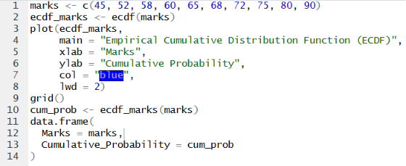

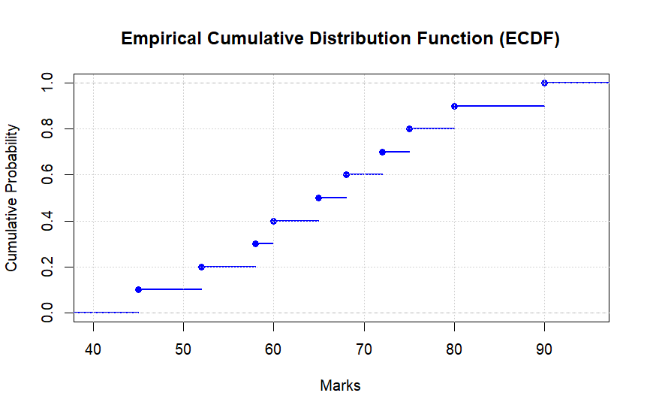

The ECDF plot shows the cumulative proportion of students scoring at or below each mark. For example, 50% of students scored 65 marks or less, 80% scored 75 marks or less, and 100% scored 90 marks or less, indicating the complete distribution of the quiz marks.

Question 2 – Empirical Cumulative Distribution Function (ECDF)
Scenario
A fitness trainer recorded the number of daily steps completed by ten participants during a health challenge.
Dataset
Participant | Daily Steps
P1 | 4200
P2 | 5000
P3 | 5600
P4 | 6100
P5 | 6800
P6 | 7200
P7 | 8100
P8 | 9200
P9 | 10400
P10 | 12000
Question
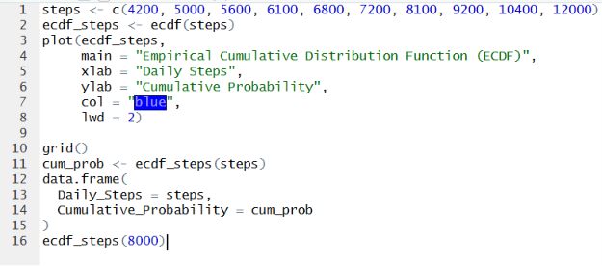

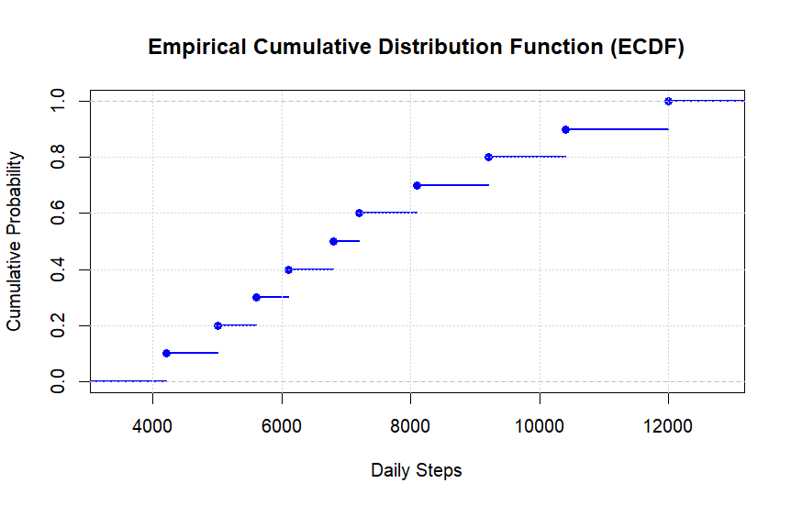

The ECDF plot shows the cumulative proportion of participants who walked at or below a given number of daily steps. It indicates that 60% of participants walked 8,000 steps or fewer, making the ECDF useful for understanding the distribution and cumulative percentages of daily step counts.

Question 3 – Highly Skewed Distribution (Histogram and Density Plot)
Scenario
An online shopping company recorded the purchase amount (₹) made by customers during a promotional sale. Most customers purchased inexpensive items, while a few made very expensive purchases.
Dataset
Customer | Purchase Amount (₹)
C1 | 250
C2 | 300
C3 | 320
C4 | 350
C5 | 380
C6 | 450
C7 | 520
C8 | 650
C9 | 1800
C10 | 5200
Question
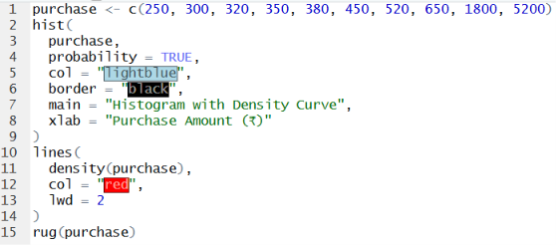

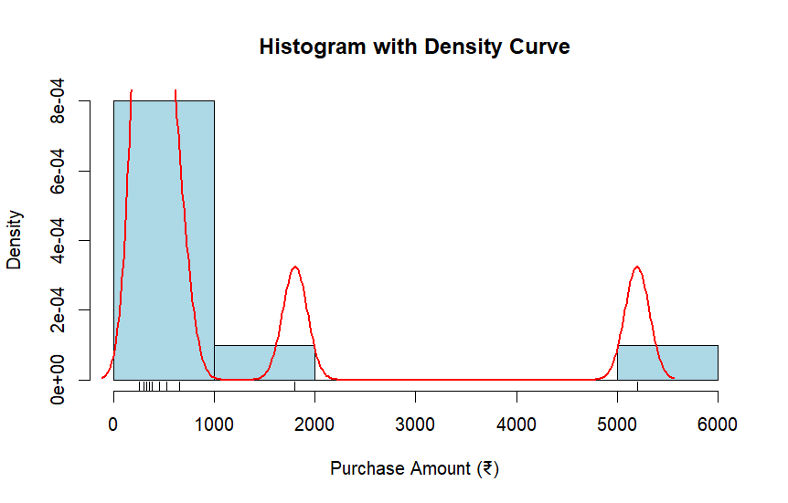

The histogram and density plot show that the distribution is positively (right) skewed. Most purchase amounts are clustered between ₹250 and ₹650, while a few very large purchases (₹1800 and ₹5200) create a long tail on the right side of the distribution.

Question 4 – Quantile-Quantile (Q-Q) Plot
Scenario
A hospital administrator collected the waiting times (in minutes) for patients in the outpatient department and wants to verify whether the data follows a normal distribution.
Dataset
Patient | Waiting Time (minutes)
P1 | 12
P2 | 15
P3 | 18
P4 | 20
P5 | 22
P6 | 24
P7 | 25
P8 | 28
P9 | 30
P10 | 32
Question
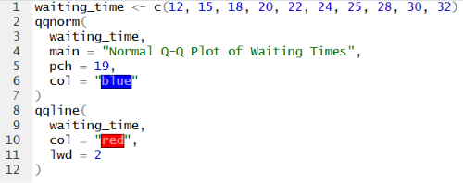

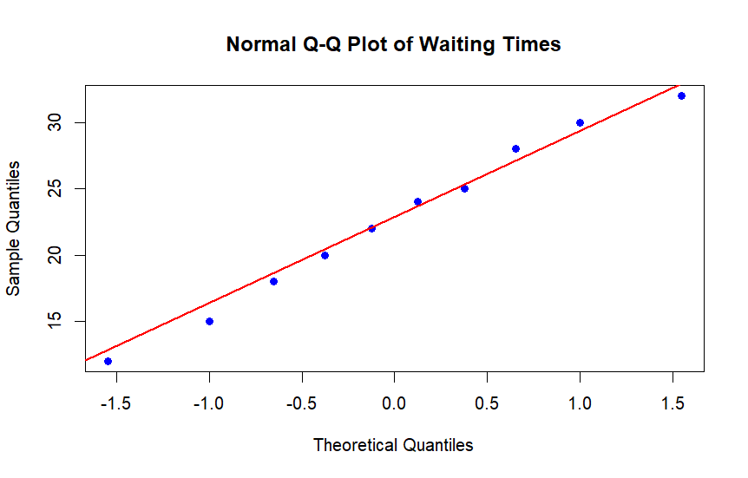

The Q-Q plot shows that the data points lie approximately along the reference line, indicating that the waiting times approximately follow a normal distribution with only minor deviations.

Question 5 – Highly Skewed Distribution and Q-Q Plot
Scenario
A bank analyzed the monthly income (₹) of ten customers applying for home loans. A few customers have exceptionally high incomes compared to the majority.
Dataset
Customer | Monthly Income (₹)
C1 | 18000
C2 | 22000
C3 | 24000
C4 | 26000
C5 | 28000
C6 | 30000
C7 | 34000
C8 | 42000
C9 | 85000
C10 | 200000
Question
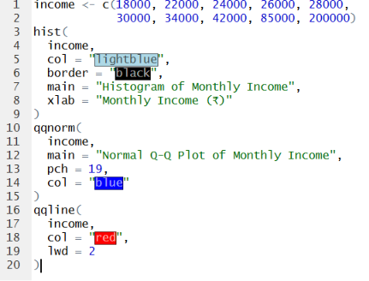

3. The income data is highly positively (right) skewed and does not follow a normal distribution.
4. The Q-Q plot supports this conclusion because the points deviate significantly from the reference line, especially in the upper tail due to the high-income outliers (₹85,000 and ₹200,000).

